**United States Airlines Analysis Excel Project**

Create an Excel dashboard showcasing the following (use form controls to make a dynamic chart):

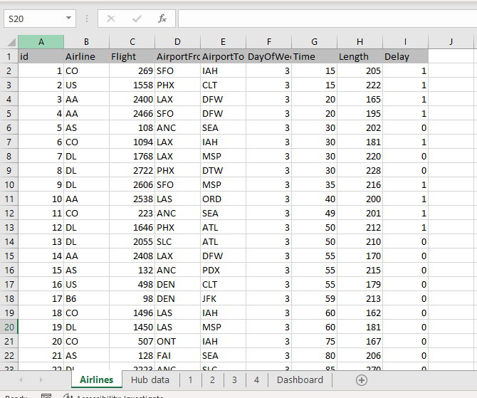

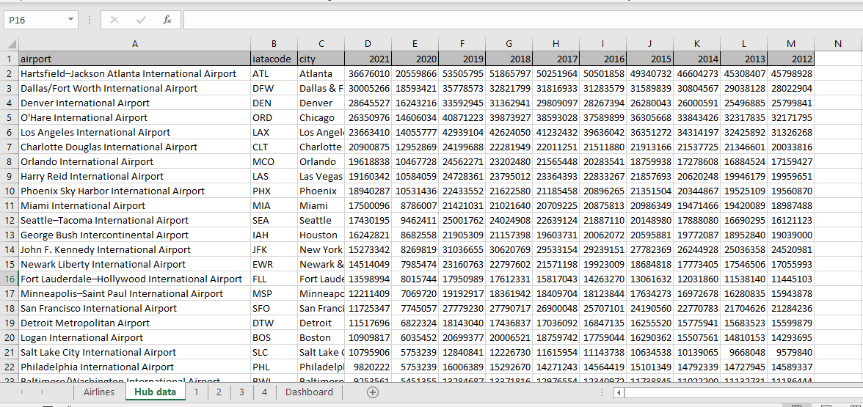

1. Compare different airlines based on their on-time performance.

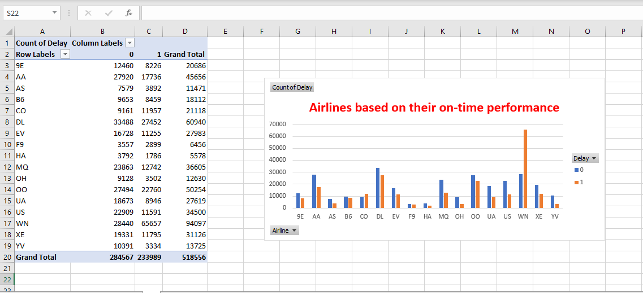

1. Compare the percentage of delayed flights for different days of the week

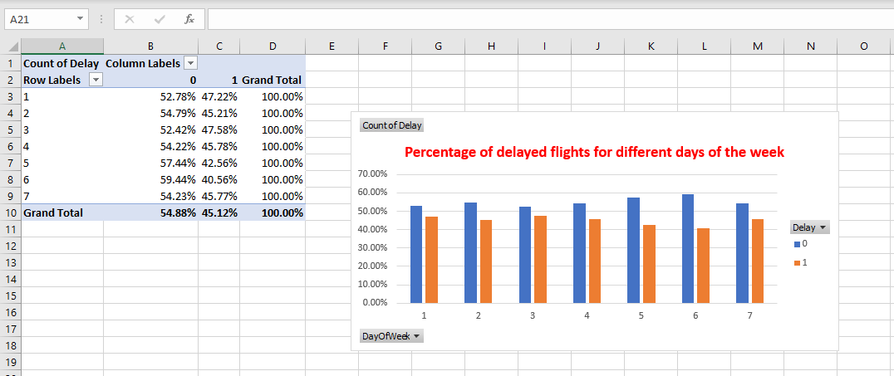

1. Create a trend chart for the number of passengers at large and medium hubs

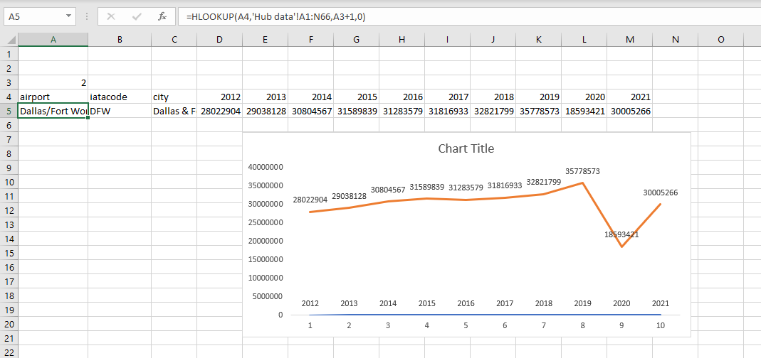

1. Visualize the count of delayed and on-time flights for different pairs of source and destination airports

* Create a dynamic chart that allows users to select a source and destination airport.

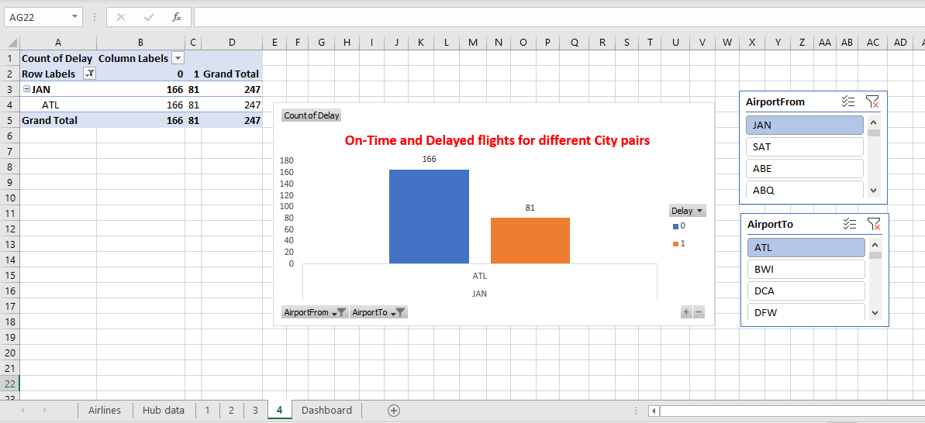

**Dashboard -**

